EVALUATION REPORT

1. Overview
This document summarizes the performance evaluation of the BOQ (Bill of Quantities) extraction model using LLM-based semantic grading, structured scoring, and row-wise evaluation on a labeled dataset.

2. Evaluation Methodology
Each prediction is compared with ground truth using a large language model judge, which assigns:

Output | Description
Score (0–10) | Numeric semantic quality rating assigned per sample
Verdict | Correct / Partial / Wrong classification
Reason | Short natural language explanation of the verdict

3. Final Results Summary

LLM Score  8.65 / 10 |  | Weighted Score  86.5% |  | Strict Accuracy  70% |  | Error Rate  0%

Metric | Value | Interpretation
Average LLM Score | 8.65 / 10 | High semantic similarity between prediction and ground truth
Weighted Score | 86.5% | Overall model quality — above 80% production threshold
Strict Accuracy | 70% | Fully correct structured outputs
Partial Match Rate | 30% | Outputs with minor missing or incorrect attributes
Error Rate | 0% | No completely incorrect predictions — excellent stability

4. Visual Performance Analysis

4.1 Evaluation Metrics Overview
The chart below compares all five evaluation metrics against the 80% production threshold (green dashed line).

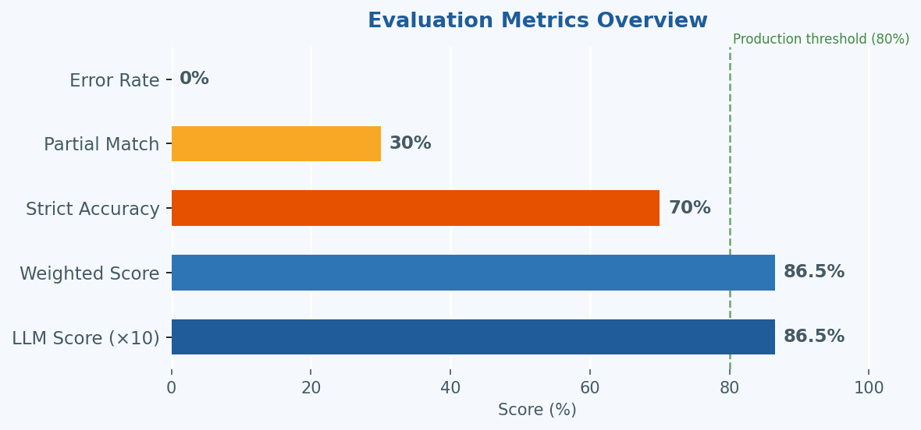
Figure 1 — Horizontal bar chart of all evaluation metrics

4.2 Verdict Distribution & Sample-Level Breakdown
The donut chart shows the proportion of Correct, Partial, and Wrong verdicts. The stacked bar shows the raw sample counts.

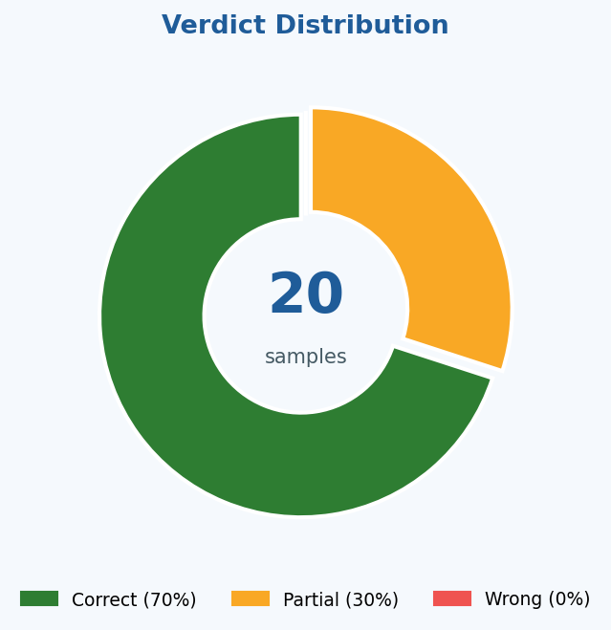
Figure 2 Verdict Distribution
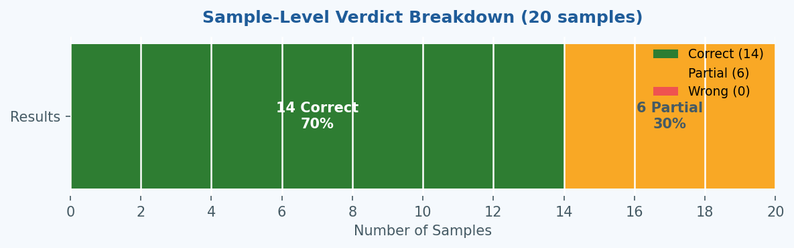
Figure 3 Samplewise Distribution ( Chart 1 )

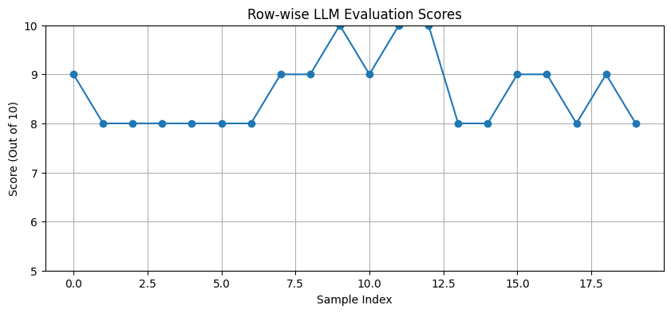
Figure 3 Samplewise Distribution ( Chart 2 )

4.3 Semantic Quality Gauge
The gauge illustrates how the model's LLM semantic score of 8.65 sits well above the 8.0 benchmark zone.

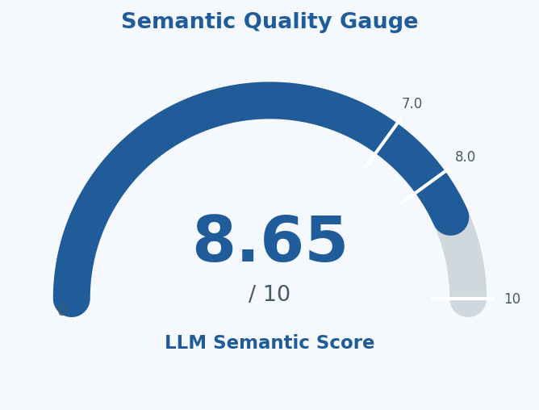
Figure 3 Semantic Quality

5. Metrics Explanation
Metric | Definition | Purpose | Ideal Range
Average LLM Score | Mean score (0–10) by LLM judge | Measures semantic correctness of BOQ | > 8 = strong
Weighted Score | Normalized LLM score as % | Overall extraction quality | > 80% = strong
Strict Accuracy | % predictions marked Correct | Fully accurate structured extraction | Higher is better
Partial Match Rate | % predictions marked Partial | Near-correct, minor gaps | Lower is better
Error Rate | % completely incorrect outputs | Failure / instability rate | 0% = excellent

